Press Release Kit for:

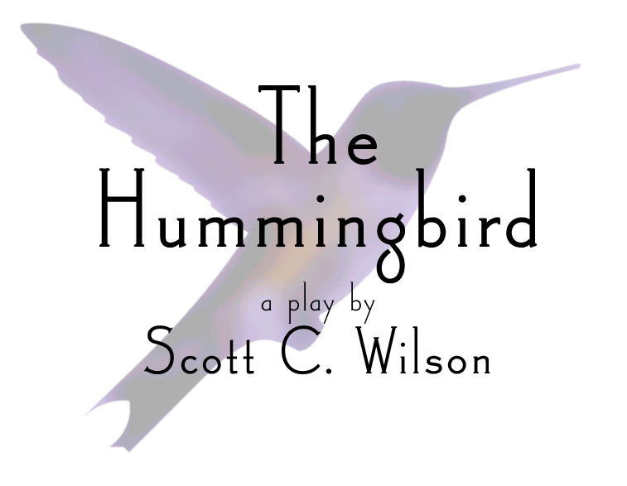

Performances September 1st, 2nd, and 3rd at 8:00 pm

At

The Kent Stage
175 E. Main St.
Kent, OH 44240

SYNOPSIS of The Hummingbird

What is the play about?
The Hummingbird is a comic tragedy in three acts. The action begins on a Friday evening just after six, at three separate locations on the same city block, in a small Midwestern college town. All three locations are juxtaposed on stage, and each story unfolds in real-time.

One space is the living room of a messy apartment shared by four college girls, each one quirkier than the next. Another space is a modest coffee shop where patrons enjoy friendly banter with the traditional Sicilian proprietor, Antonio Corbo. The third space is the art nouveau living room of Joe and Meg, a young married couple struggling to find time for each other.

Each story is connected, and the coffee shop becomes a meeting place for gossip, secret relationships, blossoming romance, and, supremely, tragedy. On his way to the coffee shop at the end of Act One, Joe bumps into Ned, a homeless drug addict who frequents the neighborhood. When Joe denies Ned the five dollar hand-out he asks for, Ned follows Joe to the coffee shop. Ned considers the circumstances at the coffee shop on this particular night favorable for an armed robbery.

Acts Two and Three present alternative endings to the story, raising questions about community identity, intervention for the homeless, and the interconnectedness of small town Americans.

*Due to adult content, including language and some violence, The Hummingbird is intended for mature audiences only.

Production History
McKay Bricker Gallery and Framing in Kent, Ohio, offered initial support for this production. Coleman Professional Services of Kent has also agreed to fund the project.

The play is currently in pre-production; rehearsals begin on August 8. In May of 2005, the playwright met with the producers (representatives from the aforementioned companies), and a timeline for the project was established. It was immediately decided to contact Mary Ann Costa, recently retired long-time theater director at Theodore Roosevelt High School (see biographies, page 1). Having worked with Scott when he attended Roosevelt from 1994-1998, Mary Ann was familiar with his diverse talents, including his vision as a playwright. After reading the script, Mary Ann agreed to direct, and Scott accepted the responsibilities of a producer.

On Friday, May 6th, Scott and Mary Ann brought together a talented group of area actors to participate in a closed cold read of The Hummingbird. The conclusion of the play was met with spontaneous applause, and the project suddenly gained both identity and the momentum and support of a committed group of artists. Many of those actors have since been cast in the play, including Roosevelt alums Jennifer Dominguez, Emily Lanier, Jessica Linkous, Jeness Duffy, Tony Dodds, Trevor Williams, and Tony Recznik. Other actors from the greater Cleveland area have been cast in the remaining roles, including Edward Borowy and Jeff Lunger.

The production staff includes Karynn Barlow, who will call on her experiences in Roosevelt’s theater program to stage manage/assistant direct. Andy Lanier and Phil Lanier, of Wideye Design, have begun the groundwork for scenic design, and young sound designer Billy Brennick, of Cleveland, has signed on for the project as well. Lighting Designer Ryan McMullen, of Cleveland, rounds out a talented design team.

Promotional Events have included a cocktail benefit and preview reading at McKay Bricker Gallery and Framing on May 27, a speech given by Wilson at the Rotary Club of Kent’s weekly luncheon on June 14, A Bottled Water Sale at the Kent HeritageFest on July 2, a happy hour at Glory Days Water Street Tavern in Kent on July 8, and a Barbecue in Parma on July 30.

Performances will take place at the Kent Stage, in downtown Kent, on Thursday, Friday, and Saturday, September 1, 2 and 3, at 8 pm.

Tickets will be on sale for $10.00 throughout the month of August at the following locations: McKay Bricker Gallery and Framing, Woodsy’s Music, and Spinmore Records, all located in Kent. Tickets will also be available at The Kent Stage on performance dates.

A Play with a Social Mission
We are pleased to announce that a portion of the proceeds generated from the performances of The Hummingbird will benefit the Mental Health and Recovery Board of Portage County (MHRBPC). For more information about the MHRBPC, please see the sheet below.

It is the greater intention of the writer, director, and others involved in the production of The Hummingbird to rekindle an active interest in drama amongst the greater Kent community. Scott imagines an annual summer’s end production that provides opportunities for up-and-coming amateur playwrights, directors, designers, and actors from the Midwest to cultivate their talents and benefit local charities, such as the MHRBPC, at the same time.

